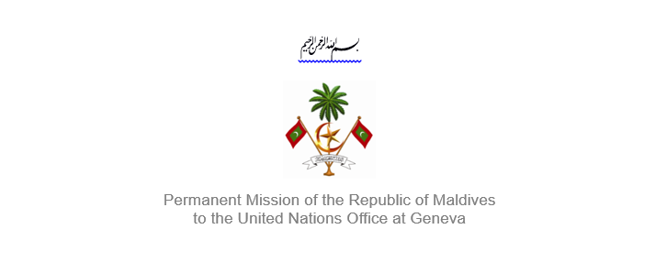25th Session of the Working Group of the Universal Periodic Review
2 – 13 May 2016, Geneva

Review of United Republic of Tanzania
9 May 2016

Statement by Her Excellency Dr. Hala Hameed, Ambassador /
Permanent Representative of Maldives to the United Nations Office at Geneva

Check against delivery

Thank you, Mr. President,

The Maldives welcomes the delegation from Tanzania to this review, led by HE Mr. Sifuni E. Mchome, Permanent Secretary at the Ministry of Constitution and Legal Affairs of the United Republic of Tanzania.

The Maldives welcomes the adoption of the New Education and Training Policy in 2014 and an Inclusive Education Strategy (IE) 2012-2017, as well as the National Anti-Trafficking in Persons Action Plan (2015–2017) and the Education and Training Policy, and the Social Protection Policy of 2014.

The Maldives would like to make the following recommendations:

- Take immediate steps to change attitude towards children with albinism and ensure protection of their human rights.

- Improve access to safe drinking water and adequate sanitation facilities.

- Strengthen efforts to end child, early and forced marriages, especially among girls

The Maldives appreciates the measures taken by Tanzania to emancipate women in rural areas by establishing 14 Women Information Windows, and encourage the Government to take steps to prevent violence against women as well as to promote the empowerment of women.

Finally, the Maldives takes note of the vulnerable effects of climate change, especially its effects on food security. We therefore urge the Tanzanian authorities to allocate adequate resources to tackle this issue.

My delegation wishes the delegation of Tanzania all the success during this review.

Thank you Mr. President.

